Arduino Tutorials

*Button*

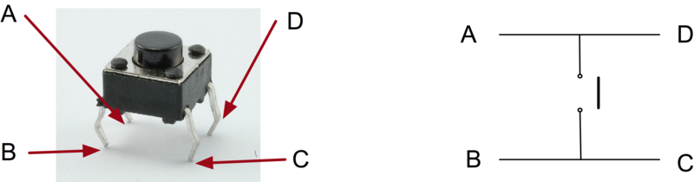

In the original state, the pin A is connected with pin D and pin B is connected with pin C. When the button is pushed, the circuit between those two wires connect together. So, the common circuit design of the button is

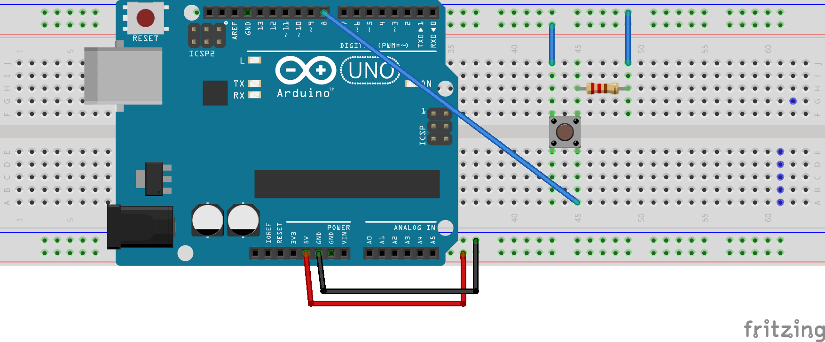

When the button is released, the pin read the LOW signal. If the button is pressed, the pin C and pin D is connected. Therefore, the pin B (pin 8) reads 5V (HIGH) signal.

*Seven Segment Display*

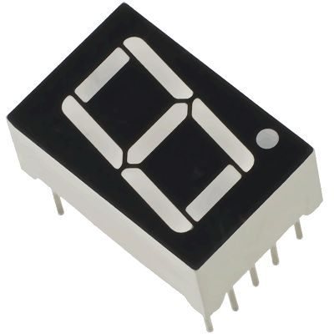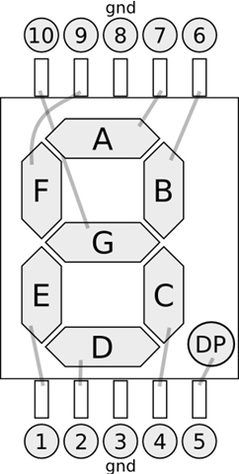

There are two types of seven segment display, common anode (共陽極) and common cathode (共陰極). The first one need to connect pin 8 and pin 3 to 5V power, then, the led is on when the pin signal is HIGH. On the other hand, the last one need to connect pin 8 & 3 to ground and the led is on when the pin signal is LOW.

For standard circuit, the display pin (without 8 and 3) need to connect with a 10 kΩ resistor in series. But, for the test result, it’s not necessary when using Mega 2560.

*Fourth Seven Segment Display*

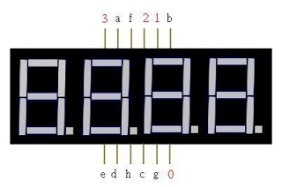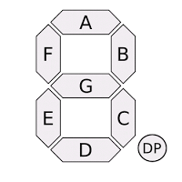

Same as single seven segment display, the pins are defined as “A” to “G”. The additional pins (pin 0 to 3) define the display position. If pin 0 is HIGH and others are LOW, the display position is set to the first bit of number.

*Sonar Sensor*

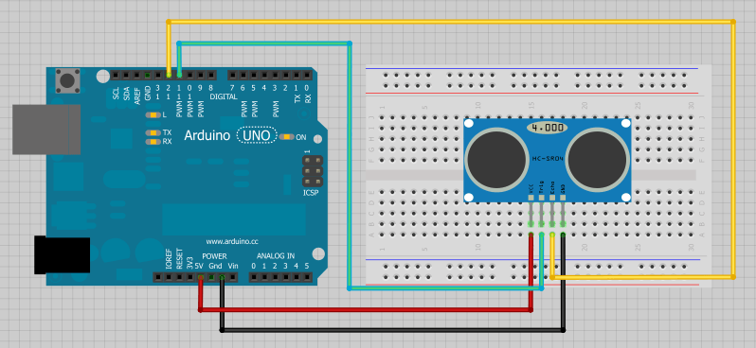

There are four pins on sonar sensor. Two of them is 5V power and ground. One is trig pin and other is echo pin.

*SD Card Storage*

*Relay*